**Chapter X Curve and Surface Design**

In computer graphics, we often need to draw different types of objects onto the screen. Objects are not flat all the time and we need to draw curves many times to draw an object.

Types of Curves

A curve is an infinitely large set of points. Each point has two neighbors except endpoints. Curves can be broadly classified into three categories − **explicit, implicit,** and **parametric curves**.

Implicit Curves

Implicit curve representations define the set of points on a curve by employing a procedure that can test to see if a point in on the curve. Usually, an implicit curve is defined by an implicit function of the form −

fx,yx,y = 0

It can represent multivalued curves multipleyvaluesforanxvaluemultipleyvaluesforanxvalue. A common example is the circle, whose implicit representation is

**x2 + y2 - R2 = 0**

Explicit Curves

A mathematical function y = fxx can be plotted as a curve. Such a function is the explicit representation of the curve. The explicit representation is not general, since it cannot represent vertical lines and is also single-valued. For each value of x, only a single value of y is normally computed by the function.

Parametric Curves

Curves having parametric form are called parametric curves. The explicit and implicit curve representations can be used only when the function is known. In practice the parametric curves are used. A two-dimensional parametric curve has the following form −

Ptt = ftt, gtt or Ptt = xtt, ytt

The functions f and g become the x,yx,y coordinates of any point on the curve, and the points are obtained when the parameter t is varied over a certain interval [a, b], normally [0, 1].

Bezier Curves

Bezier curve is discovered by the French engineer **Pierre Bézier**. These curves can be generated under the control of other points. Approximate tangents by using control points are used to generate curve. The Bezier curve can be represented mathematically as −

∑k=0nPiBni(t)∑k=0nPiBin(t)

Where pipi is the set of points and Bni(t)Bin(t) represents the Bernstein polynomials which are given by −

Bni(t)=(ni)(1−t)n−itiBin(t)=(ni)(1−t)n−iti

Where **n** is the polynomial degree, **i** is the index, and **t** is the variable.

The simplest Bézier curve is the straight line from the point P0P0 to P1P1. A quadratic Bezier curve is determined by three control points. A cubic Bezier curve is determined by four control points.

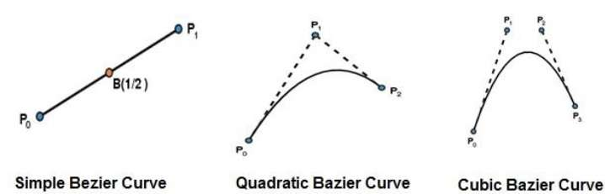

Properties of Bezier Curves

Bezier curves have the following properties −

* They generally follow the shape of the control polygon, which consists of the segments joining the control points.
* They always pass through the first and last control points.
* They are contained in the convex hull of their defining control points.
* The degree of the polynomial defining the curve segment is one less that the number of defining polygon point. Therefore, for 4 control points, the degree of the polynomial is 3, i.e. cubic polynomial.
* A Bezier curve generally follows the shape of the defining polygon.
* The direction of the tangent vector at the end points is same as that of the vector determined by first and last segments.
* The convex hull property for a Bezier curve ensures that the polynomial smoothly follows the control points.
* No straight line intersects a Bezier curve more times than it intersects its control polygon.
* They are invariant under an affine transformation.
* Bezier curves exhibit global control means moving a control point alters the shape of the whole curve.
* A given Bezier curve can be subdivided at a point t=t0 into two Bezier segments which join together at the point corresponding to the parameter value t=t0.

B-Spline Curves

The Bezier-curve produced by the Bernstein basis function has limited flexibility.

* First, the number of specified polygon vertices fixes the order of the resulting polynomial which defines the curve.
* The second limiting characteristic is that the value of the blending function is nonzero for all parameter values over the entire curve.

The B-spline basis contains the Bernstein basis as the special case. The B-spline basis is non-global.

A B-spline curve is defined as a linear combination of control points Pi and B-spline basis function Ni,Ni, k tt given by

C(t)=∑ni=0PiNi,k(t),C(t)=∑i=0nPiNi,k(t), n≥k−1,n≥k−1, tϵ[tk−1,tn+1]tϵ[tk−1,tn+1]

Where,

* {pipi: i=0, 1, 2….n} are the control points
* k is the order of the polynomial segments of the B-spline curve. Order k means that the curve is made up of piecewise polynomial segments of degree k - 1,
* the Ni,k(t)Ni,k(t) are the “normalized B-spline blending functions”. They are described by the order k and by a non-decreasing sequence of real numbers normally called the “knot sequence”.

ti:i=0,...n+Kti:i=0,...n+K

The Ni, k functions are described as follows −

Ni,1(t)={1,0,ifuϵ[ti,ti+1)OtherwiseNi,1(t)={1,ifuϵ[ti,ti+1)0,Otherwise

and if k > 1,

Ni,k(t)=t−titi+k−1Ni,k−1(t)+ti+k−tti+k−ti+1Ni+1,k−1(t)Ni,k(t)=t−titi+k−1Ni,k−1(t)+ti+k−tti+k−ti+1Ni+1,k−1(t)

and

tϵ[tk−1,tn+1)tϵ[tk−1,tn+1)

Properties of B-spline Curve

B-spline curves have the following properties −

* The sum of the B-spline basis functions for any parameter value is 1.
* Each basis function is positive or zero for all parameter values.
* Each basis function has precisely one maximum value, except for k=1.
* The maximum order of the curve is equal to the number of vertices of defining polygon.
* The degree of B-spline polynomial is independent on the number of vertices of defining polygon.
* B-spline allows the local control over the curve surface because each vertex affects the shape of a curve only over a range of parameter values where its associated basis function is nonzero.
* The curve exhibits the variation diminishing property.
* The curve generally follows the shape of defining polygon.
* Any affine transformation can be applied to the curve by applying it to the vertices of defining polygon.
* The curve line within the convex hull of its defining polygon.

Polygon Surfaces

Objects are represented as a collection of surfaces. 3D object representation is divided into two categories.

* **Boundary Representations**B−repsB−reps − It describes a 3D object as a set of surfaces that separates the object interior from the environment.
* **Space–partitioning representations** − It is used to describe interior properties, by partitioning the spatial region containing an object into a set of small, non-overlapping, contiguous solids usuallycubesusuallycubes.

The most commonly used boundary representation for a 3D graphics object is a set of surface polygons that enclose the object interior. Many graphics system use this method. Set of polygons are stored for object description. This simplifies and speeds up the surface rendering and display of object since all surfaces can be described with linear equations.

The polygon surfaces are common in design and solid-modeling applications, since their **wireframe display** can be done quickly to give general indication of surface structure. Then realistic scenes are produced by interpolating shading patterns across polygon surface to illuminate.

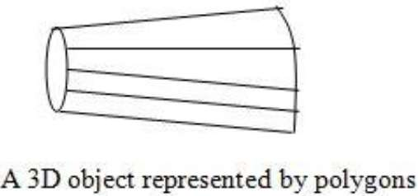

Polygon Tables

In this method, the surface is specified by the set of vertex coordinates and associated attributes. As shown in the following figure, there are five vertices, from v1 to v5.

* Each vertex stores x, y, and z coordinate information which is represented in the table as v1: x1, y1, z1.
* The Edge table is used to store the edge information of polygon. In the following figure, edge E1 lies between vertex v1 and v2 which is represented in the table as E1: v1, v2.
* Polygon surface table stores the number of surfaces present in the polygon. From the following figure, surface S1 is covered by edges E1, E2 and E3 which can be represented in the polygon surface table as S1: E1, E2, and E3.

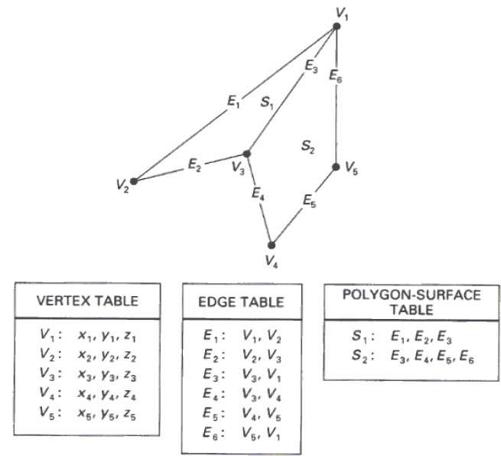

Plane Equations

The equation for plane surface can be expressed as −

Ax + By + Cz + D = 0

Where x,y,zx,y,z is any point on the plane, and the coefficients A, B, C, and D are constants describing the spatial properties of the plane. We can obtain the values of A, B, C, and D by solving a set of three plane equations using the coordinate values for three non collinear points in the plane. Let us assume that three vertices of the plane are (x1, y1, z1), (x2, y2, z2) and (x3, y3, z3).

Let us solve the following simultaneous equations for ratios A/D, B/D, and C/D. You get the values of A, B, C, and D.

A/DA/D x1 + B/DB/D y1 + C/DC/D z1 = -1

A/DA/D x2 + B/DB/D y2 + C/DC/D z2 = -1

A/DA/D x3 + B/DB/D y3 + C/DC/D z3 = -1

To obtain the above equations in determinant form, apply Cramer’s rule to the above equations.

A=⎡⎣⎢111y1y2y3z1z2z3⎤⎦⎥B=⎡⎣⎢x1x2x3111z1z2z3⎤⎦⎥C=⎡⎣⎢x1x2x3y1y2y3111⎤⎦⎥D=−⎡⎣⎢x1x2x3y1y2y3z1z2z3⎤⎦⎥A=[1y1z11y2z21y3z3]B=[x11z1x21z2x31z3]C=[x1y11x2y21x3y31]D=−[x1y1z1x2y2z2x3y3z3]

For any point x,y,zx,y,z with parameters A, B, C, and D, we can say that −

* Ax + By + Cz + D ≠ 0 means the point is not on the plane.
* Ax + By + Cz + D < 0 means the point is inside the surface.
* Ax + By + Cz + D > 0 means the point is outside the surface.

Polygon Meshes

3D surfaces and solids can be approximated by a set of polygonal and line elements. Such surfaces are called **polygonal meshes**. In polygon mesh, each edge is shared by at most two polygons. The set of polygons or faces, together form the “skin” of the object.

This method can be used to represent a broad class of solids/surfaces in graphics. A polygonal mesh can be rendered using hidden surface removal algorithms. The polygon mesh can be represented by three ways −

* Explicit representation
* Pointers to a vertex list
* Pointers to an edge list

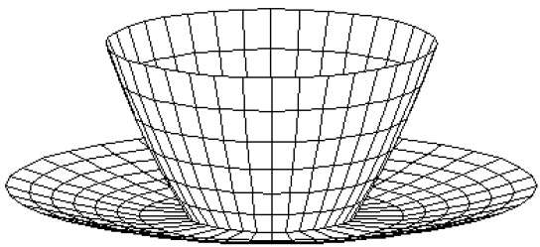

Advantages

* It can be used to model almost any object.
* They are easy to represent as a collection of vertices.
* They are easy to transform.
* They are easy to draw on computer screen.

Disadvantages

* Curved surfaces can only be approximately described.
* It is difficult to simulate some type of objects like hair or liquid.